Recipe For
The Pet Glider Fresh Diet
This recipe is enough for 2 gliders for 30 days
This recipe is enough for 2 gliders for 30 days
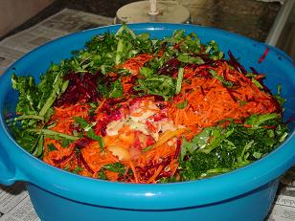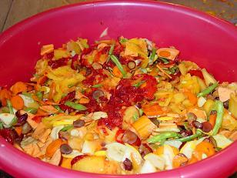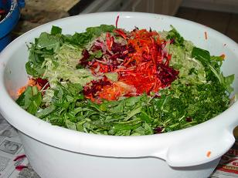
Note to those currently on The Pet Glider Exotic Diet:
We have not changed our base recipe. The following recipe is formulated with two gliders in mind.
You can continue to prepare it the way you always have, do not let this confuse you!
Notes to the beginner chef and the seasoned cook: Nutritional variety is important for healthy, happy sugar gliders. We recommend that you try making several versions of this recipe (changing the fruits, veggies and protein) at one time so you can feed your gliders a variety during the month. However, if time does not allow for this, be sure you change up your recipe on a monthly basis and give them a variety of healthy treats.

Amount | Ingredient | Notes
8 ounces / 1 cup | Fresh or Frozen Fruit  At least 4 different types  Not Canned  Either finely chop or use a food processor. | Favorites include: oranges, papayas, tangerines, pineapples, mangos, cantaloupes, bananas, kiwi, peaches, strawberries, blueberries, raspberries and cherries that have been pitted. If you peel a fruit before you eat it, then peel it for your sugar glider.  DO NOT FEED RHUBARB.
8 ounces / 1 cup | Fresh or Frozen Vegetables  At least 4 different types  Not Canned  Either finely chop or use a food processor. | Vegetables – fresh or frozen - not canned. When using frozen vegetables, get regular mixes (no sauces or Asian flavoring). Favorites include: sweet potatoes, kale, collards, green beans, , beets, peas, lima beans, carrots, jicama, bok choy, squash, red bell pepper and snow peas. Small amounts of corn are ok but be very careful. Corn is high in phosphorus and it is fattening and of course sugar gliders love corn so they will always eat that first. Small amounts of broccoli and cauliflower are ok, but overdoing produces excess gas in the sugar glider and that makes them very grumpy. DO NOT FEED GARLIC, LEEKS OR ONIONS OF ANY KIND.
6 ounces | Plain (full fat) Yogurt - No Artificial Sweeteners | Such as Stoneyfield Farm or Dannon
3 ounces | Calcium Fortified Orange Juice Concentrate | You can substitute regular orange juice if you are unable to find one that is calcium fortified.
2-3 ounces | Uncooked oatmeal | Use five minute regular oats, not the quick cooking kind. The oatmeal is nutritious and thickens your mix. More or less will be needed depending on the water generated by your fruits and vegetables
32 ounces / 4 cups | Applesauce | Unsweetened is best
6 ounces | Protein | Protein – Favorites include cooked chicken, ground turkey and eggs. You can boil, broil or roast the chicken, pan cook the ground turkey using extra virgin olive oil and scramble the eggs. We do not recommend you give your sugar gliders pork or beef because of the high fat content and once again, fat gliders are not happy and health.
1 tablespoon | Ground flax seed or wheat germ (Optional) | This is optional if you are using fresh fruits and vegetables.

Directions:
1. Finely chop your fruits and vegetables. We recommend using a food processor. If you do not have one, make sure you chop your fruits and vegetables into small pieces. Remember the size of the animal you are preparing food for.
2. Cook your protein – chicken, turkey, or eggs.
3. In a large bowl, put all ingredients except the oatmeal and stir vigerously. You want to make sure all ingredients have been incorporated and mixed thoroughly.
4. Depending on the thickness of your mix, add oatmeal. You do not want a runny or too thick of a mix, but one that has the consistency of a cake mix.
5. You will want to divide the mixture in smaller containers to freeze. Here are some recommendations.
a. Use ice cube trays. Measure two tablespoons of the mixture into the individual ice cube holes. After they have frozen, you can pop them out, put them in a freezer bag, then into a plastic freezer container and take out to thaw on a daily basis to feed your babies. You also have the option to feed the portions frozen because they do thaw quickly.
b. Or you can divide your mixture into 10 smaller containers and freeze. Each container will last 2 gliders for 3 days. You would not want to divide your mixture into larger containers because you want the mixture to be fresh. You do not want the mixture to be in the refrigerator longer than 3 days.
6. Sprinkle your multi-vitamin with calcium on top of the food your serve each day. Use 1/8th teaspoon of vitamins per sugar glider. Always keep your multi-vitamins with calcium powder in the refrigerator, but do not freeze.
You can also watch our super glider video on preparing fresh diets and other scrumptious meals for your pet glider. Find all kinds of tasty sugar glider treats at our store! We are the leading supplier of sugar glider food and supplies in Austin, San Antonio, and Houston, TX.

